**R Competency and the Drivetrain Approach to Decision Making**

**Minerva Schools at KGI**

**CS112**

**Professor Diamond**

**1/25/2019**

The following analysis is looking at data on Multilateral Development Institutions

1. **When projects are approved, they are approved for a certain period of time (until the time “original completion date”). While projects are active, this original completion date is often pushed out (extended, and then there is a revised completion date**

**You have been told that project duration at approval is generally about 2 years (24 months). In other words, (purportedly) when projects are approved, the difference between the original project completion date and the approval date is (supposedly) approximately 24 months.**

1. **Is this Claim true?**

Looking at the table and histogram below, we can see that most of the projects are aiming for a completion date close to 2 years from the approval. The mean here is 1.764 with a median of 1.622 years. A quarter of the projects have a target duration of less than approximately 1 year (1.093) with a minimum of 0.049 years and a quarter of the projects are aiming for a duration of more than 2.145years with a maximum of 9.231years. We see that the distribution has a larger tail to the right than the left and the majority of projects aim for about 2 years, arguably slightly less, but about 2 years seems like a reasonable estimate.

|  |  |  |  |  |  |
| --- | --- | --- | --- | --- | --- |
| Minimum | 1st quartile | Median | Mean | 3rd quartile | Maximum |
| 0.049 | 1.093 | 1.622 | 1.764 | 2.145 | 9.231 |

Figure 1 Table showing important metrics for the distribution of data (all values in years)

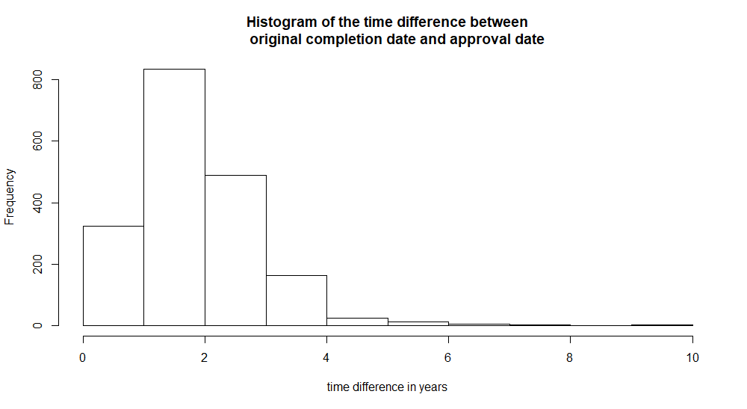

Figure 2 A Histogram showing the frequency of different project durations

**Has project duration at approval changed over time?**

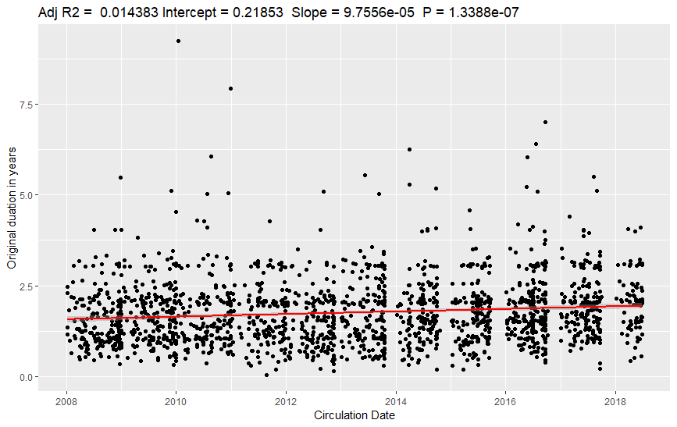The graph below shows the change in project duration over the Circulation date. As we can see, the slope is almost 0 ($9.75*{10}^{-05}$) with a low R^2 of 0.0143, meaning the data is fairly random.

Figure 3 A scatter plot showing the change in intended duration over the time of completion. We cannot observe a significant correlation between the two variables

1. 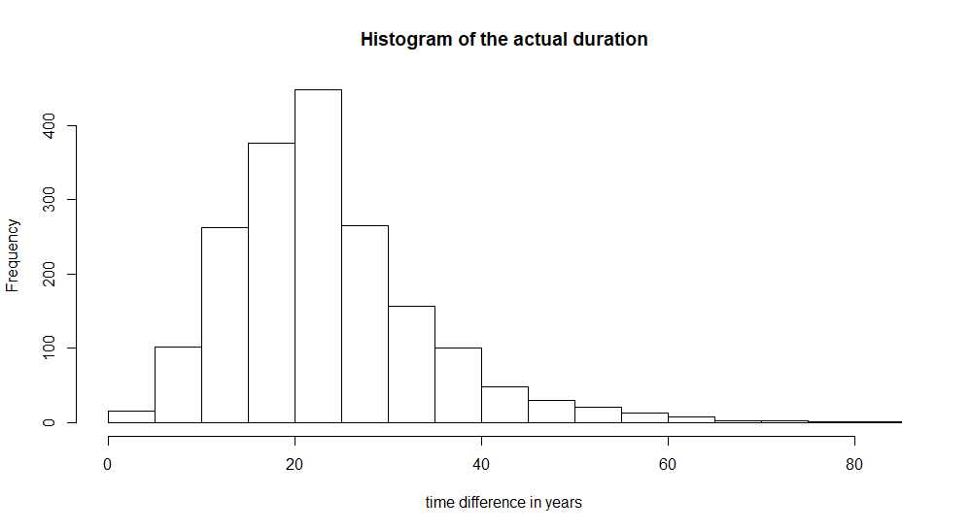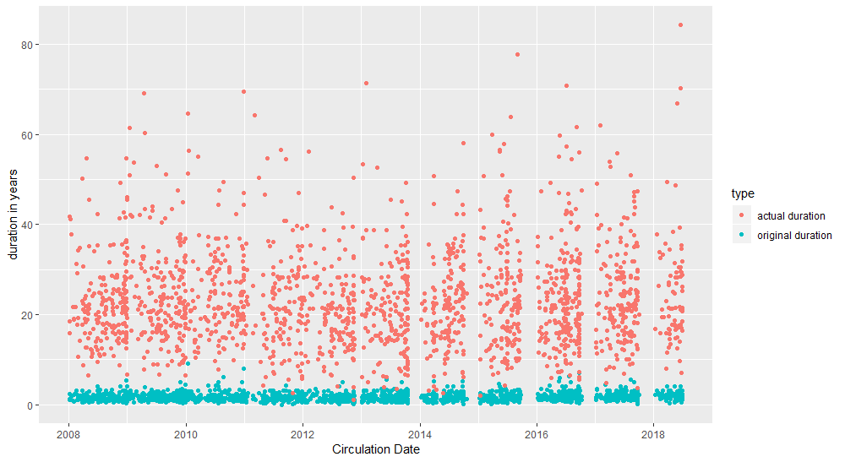**How does original planned project duration differ from actual duration (if actual duration measured as the duration between “ApprovalDate” and “RevisedCompletionDate”?)**

Figure 4 A histogram showing the distribution of the actual duration

Figure 5 a scatterplot showing the distribution of the actual duration and original duration over the completion date. We can clearly see the significantly higher actual duration.

Two plots and a table can help us compare the differences between the original duration and actual duration. The difference is astonishing: In reality, almost none of the projects get done in the planned timeframe, but take multiple times longer. The actual minimum duration is 1.074 years, the first quartile of projects takes between the minimum and 16.11 year, the median is 21.50 years, the third quartile goes up to 23.37 years and the actual maximum duration is 84.29 years.

On the histogram we see that the distribution of durations is approximately similar for the actual and original duration, but the actual mean is closer to 20 than 2 years, with an exact mean of 23.35 years.

Figure 6 table comparing the distribution parameters for the original and actual project duration

|  |  |  |  |  |  |  |
| --- | --- | --- | --- | --- | --- | --- |
| type | Minimum | 1st quartile | Median | Mean | 3rd quartile | Maximum |
| Original duration | 0.049 | 1.093 | 1.622 | 1.764 | 2.145 | 9.231 |
| Actual duration | 1.074 | 16.11 | 21.50 | 23.35 | 23.37 | 84.29 |

1. **What % of projects that have ratings were rate 0?**

**What % were rated 1? What % were rated 2? What % were rated 3?** 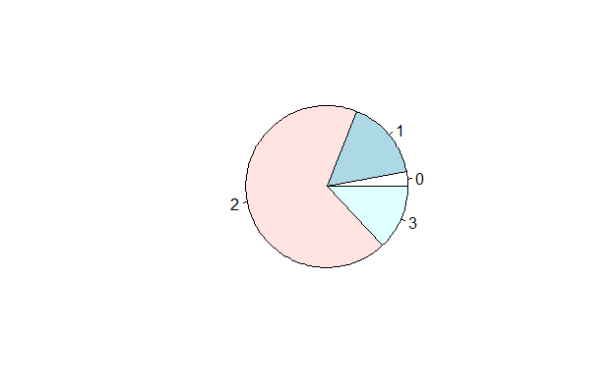

Figure 7 a pie chart showing the proportion of projects that got a certain rating

The table and pie chart above show that only 3% of projects receive a 0-rating, 16% a rating of 1, over half (68%) a rating of 2 and again a smaller percentage of 13 the highest rating of 3. The mean rating for all projects was 1.92.

|  |  |  |  |  |
| --- | --- | --- | --- | --- |
| Rating | 0 | 1 | 2 | 3 |
| % of projects | 3 | 16 | 68 | 13 |

Figure 8 a table showing the percentages of project with each of the ratings.

1. **Repeat problem 2, but this time exclude all PPTA projects. PPTA projects are more prone to negative ratings, because after a certain point in time only the low-rated PPTA projects required ratings. PPTA stands for “Project Preparatory Technical Assistance” and is basically a project intentded to zset up a loan (often a very large multi-million-dollar loan). Only PPTAs that fail to “eventuate” to a loan are rated, which is why they are usually rated negatively.**

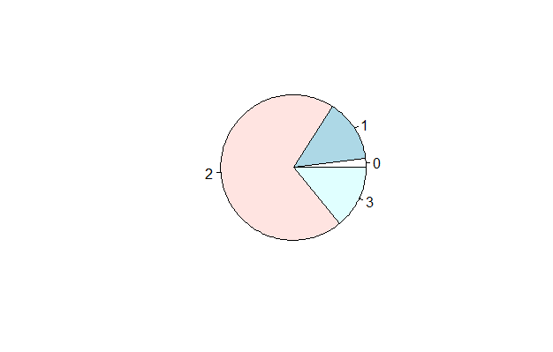When we exclude the PPTA projects, we see a small decrease in the percentage of lower-rated projects and a small increase in the percentage of higher-rated projects. The overall mean rating increased from 1.92 to 1.96

Figure 9 a pie chart showing the proportions of projects with a certain rating

|  |  |  |  |  |
| --- | --- | --- | --- | --- |
| Rating | 0 | 1 | 2 | 3 |
| % of projects | 3 | 16 | 68 | 13 |
| % of projects excluding PPTA | 2 | 14 | 70 | 14 |

Figure 10 A table showing the increase in ratings when the PPTA projects are taken out

1. **Identify the top 25% of projects by “RevisedAmount” and the bottom 25% of projects by “RevisedAmount”. (“RevisedAmount” shows the final project budget.)**

**Compare the ratings of these projects. Can you draw a causal conclusion about the effect of budget size on ratings? Why or why not?**

1. **Imagine your manager asks you to apply Jeremy Howard’s drivetrain model to the problem of optimal budget-setting to maximize project success (i.e., “Rating”).**

**In such a situation, what would be the:**

1. **Decision problem or objective?**

Optimizing the rating of the projects supported

1. **Lever or levers?**

The budget given to each project.

Potentially the organization also has power over the deadlines set (“CompletionData”). This would however not be the independent variable we are investigating to find the optimal budget-setting, but rather a confounding variable.

1. **Ideal RCT design?**

For a randomized controlled trial, we would want each project to randomly be assigned a different treatment (budget size) and try to minimize confounding variables like “CompletionDate”. For the variables we do cannot control, like the country or type, we would want to get a diverse treatment within the group, so we can more easily check for the significance of these factors later.

1. **Dependent variable and independent variable(s) in the modeler**

Independent variable: the budget the project was assigned

Dependent variable: project success

1. **And—Why would running RCTs and modeling/optimization over RCT results be preferable to using (observational, non-RCT) “mdid” data?**

The problem with observational data is that there are a lot of confounding variables that are amplified by the lack of standardization. Projects might be getting an increase in budged because they are not doing well, pulling down the rating of high-budget projects. Or they might be a PPTA project that has a lower rating not necessarily for the budget, but because it took too long to eventuate. These kind of circumstances make it impossible to draw a causal relationship from the observational data.